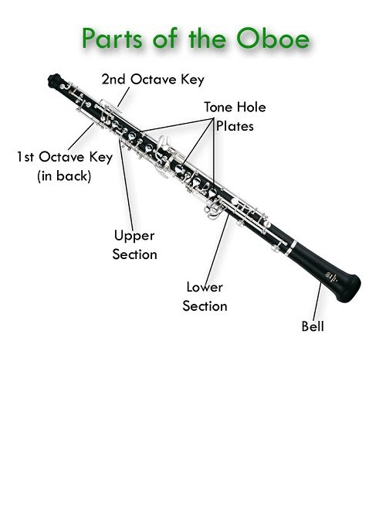

Putting it together!

* Insert the lower section into the bell
* Connect the lower section to the upper section
  + Be careful to align the tone holes before putting the parts together
  + Twist the sections only slightly so the metal bars do not push against each other

Peter Hirschhorn

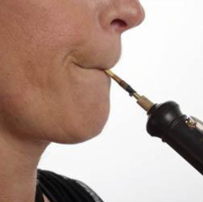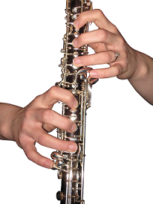

**Embouchure (OM-BO-SHURE) Checklist:**

1. Imagine sucking on a straw
2. Keep your mouth relaxed over the reed
3. Don’t bite the reed!
4. Blow “hoo” until you hear sound
5. Move the reed back and forth and see how that affects pitch
6. Add and remove pressure and see how that affects pitch
7. Use more and less air and see how that affects pitch
8. Find stability

* Left hand on top
  + First three fingers coving the top three keys with small holes on the key.
  + Thumb beneath register key
  + Pinky resting on side keys
* Right on bottom
  + First three fingers coving the bottom three keys with small holes on the key.
  + Pinky on the bottom cluster of keys
  + Thumb underneath the thumb rest
* Relax your hand. Fingers should be relaxed and slightly curved

THREE NOTES!!

B : Left hand first finger. Right hand relaxed, resting on the keys without pressing

D : Left hand first finger and second finger

G: Left hand first three fingers

You are ready to play Hot Cross Buns!