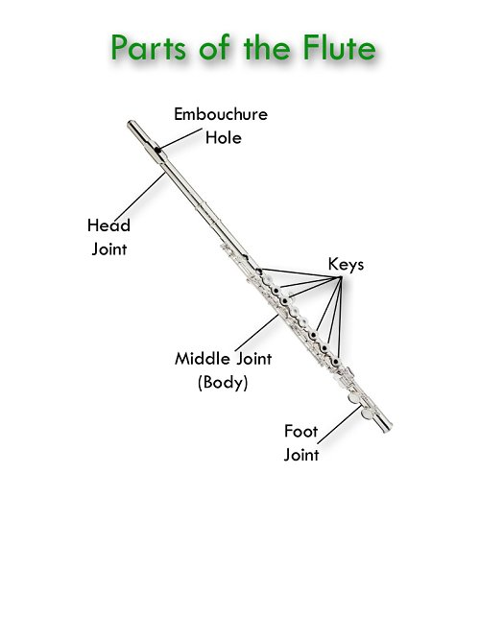

Peter Hirschhorn

Putting it together!

* Insert the head joint into the body
  + Line the embouchure hole up with the keys, then pivot slightly so it is about ¼ inch offset. This should be comfortable when you hold the flute in playing position
* Insert the foot joint into the body
  + The keys should be lined up, and then adjusted so your pinky falls naturally and comfortably on the key.

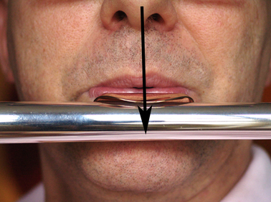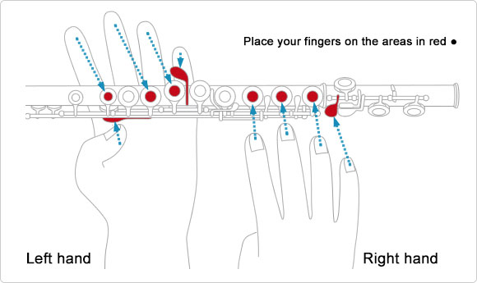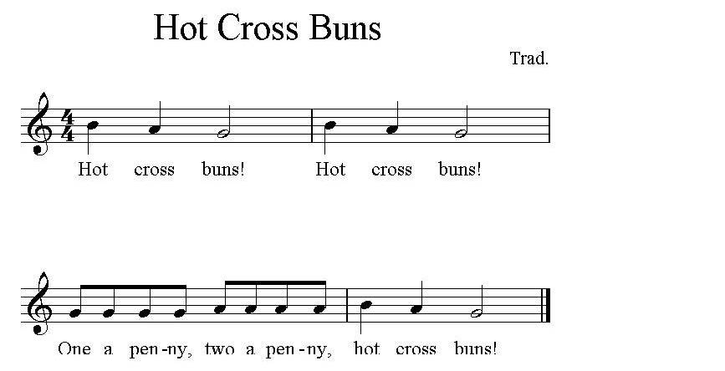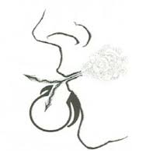

**Embouchure (OM-BO-SHURE) Checklist:**

1. Curl bottom lip over bottom teeth like you are putting on chapstick
2. Flatten out your chin
3. Pull the corners of your mouth down, like the lip plate gently against you’re the skin just under your lower lip, slightly lower than you think
4. Tighten up the space between your lips, creating a hole small enough to hold a grain of rice. This is your APERTURE (Aaa- pah – chure)
5. Move your chin back and forth, allowing for space between your back teeth. Get used to this feeling.
6. Set your Embouchure on the headjoint by itself
7. Breath in deeply
8. Blow across the embouchure hole, so the air splits the metal like in the picture
   1. Move your chin back and forth until you hear sound
9. Adjust your air speed until you create a consistent sound
   1. Blowing as hard as you can will not create the best sound, but blowing to soft will not make sound at all

THREE NOTES!!

B : Left hand first finger and thumb pressed. Right hand relaxed, resting on the keys without pressing

D : Left hand first finger, second finger, and thumb

C: Left hand first three fingers and thumb.

You are ready to play Hot Cross Buns!

* Left hand close to face
  + Thumb on bottom key
  + Pinky on side key
* Right hand in back
  + Top three fingers on back three circular keys before the foot joint
  + Pinky on the first key on the foot joint
* Relax your hand. Fingers should be relaxed and slightly curved