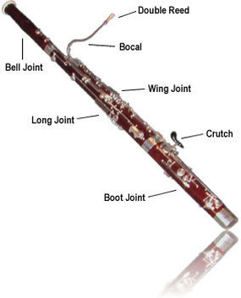

Putting it together!

* Place the reed in a cup of water
* Insert the wing joint (shorter) into the boot joint
* Insert the long joint into the boot joint, lining it up with the wing joint
* Attach the bell to the long joint
* Screw in the crutch
* Insert the bocal to the wing joint
  + Hold the bocal by the curved section near the cork, NOT by the reed end
* Attach either the seatbelt or neckstrap to the boot joint
* Gently attach the reed to the bocal

Peter Hirschhorn

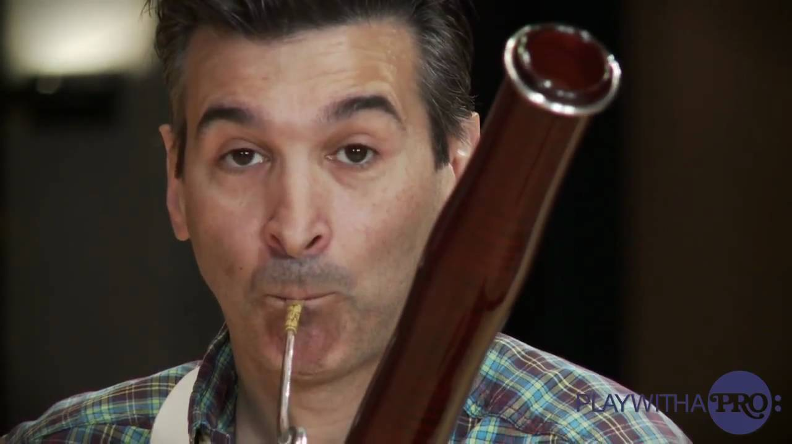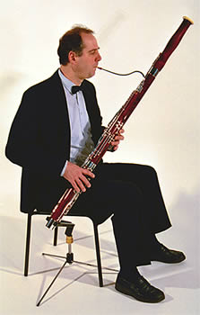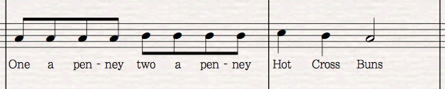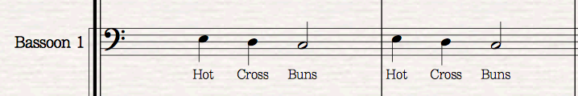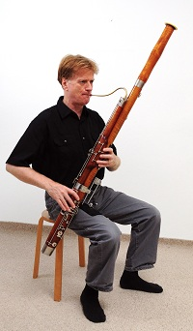

**Embouchure (OM-BO-SHURE) Checklist:**

1. Imagine sucking on a straw
2. Keep your mouth relaxed over the reed
3. Don’t bite the reed!
4. Imagine you have a golf ball in the back of your mouth
5. Blow “hoo” until you hear sound
6. Move the reed back and forth and see how that affects pitch
7. Add and remove pressure and see how that affects pitch
8. Use more and less air and see how that affects pitch
9. Find stability

* Left hand on top
  + First three fingers coving the top three tone holes (not the metal keys.
  + Thumb gently resting on one of the thumb keys farther from your palm
  + Pinky resting on side keys
* Right on bottom
  + First two fingers covering tone holes
  + Third finger on the long key beneath the tone holes
  + Thumb resting on large, flat key in back
* Relax your hand. Fingers should be relaxed and slightly curved

THREE NOTES!!

E: Left hand first finger. Right hand relaxed, hovering closely over the tone holes without touching

B : Left hand first finger and second finger

C: Left hand first three fingers

You are ready to play Hot Cross Buns!